**VISVESVARAYA TECHNOLOGICAL UNIVERSITY**

**“JnanaSangama”, Belgaum -590014, Karnataka.**



**LAB REPORT**

**on**

**MACHINE LEARNING**

**(20CS6PCMAL)**

***Submitted by***

**PRITHVI J (1BM19CS122)**

***in partial fulfillment for the award of the degree of***

**BACHELOR OF ENGINEERING**

***in***

**COMPUTER SCIENCE AND ENGINEERING**



**B.M.S. COLLEGE OF ENGINEERING**

**(Autonomous Institution under VTU)**

**BENGALURU-560019**

**May-2022 to July-2022**

**B. M. S. College of Engineering,**

**Bull Temple Road, Bangalore 560019**

(Affiliated To Visvesvaraya Technological University, Belgaum)

**Department of Computer Science and Engineering**



**CERTIFICATE**

This is to certify that the Lab work entitled “**MACHINE LEARNING**” was carried out by  **PRITHVI J (1BM19CS122),** who is a bona fide student of **B. M. S. College of Engineering.** It is in partial fulfillment for the award of **Bachelor of Engineering in Computer Science and Engineering** of the Visvesvaraya Technological University, Belgaum during the year 2022. The Lab report has been approved as it satisfies the academic requirements in respect of the course **MACHINE LEARNING (20CS6PCMAL)** work prescribed for the said degree.

Name of the Lab-In charge               **SARITHA A.N**

Designation Assistant Professor

Department of CSE Department of CSE

BMSCE, Bengaluru BMSCE, Bengaluru

`

**Index Sheet**

|  |  |  |
| --- | --- | --- |
| **Sl. No.** | **Experiment Title** | **Page No.** |
| **1.** | **FIND-S :-** Implement and demonstrate the FIND-S algorithm for finding the most specific hypothesis based on a given set of training data samples. | **2** |
| **2.** | **CANDIDATE ELIMINATION :-** For a given set of training data examples stored in a .CSV file, implement and demonstrate the Candidate-Elimination algorithm to output a description of the set of all hypotheses consistent with the training examples. | **9** |
| **3.** | **ID3 :-** Write a program to demonstrate the working of the decision tree based ID3 algorithm. Use an appropriate data set for building the decision tree and apply this knowledge to classify a new sample. | **18** |
| **4.a.** | **NAÏVE BAYESIAN CLASSIFIER** :- Write a program to implement the naïve Bayesian classifier for a sample training data set stored as a .CSV file. Compute the accuracy of the classifier, considering few test data sets | **31** |
| **4.b.** | **NAÏVE BAYESIAN CLASSIFIER (Without packages) :-** Write a program to implement the naïve Bayesian classifier for a sample training data set stored as a .CSV file. Compute the accuracy of the classifier, considering few test data sets.(Without packages) | **39** |
| **5.** | **LINEAR REGRESSION :-** Implement the Linear Regression algorithm in order to fit data points. Select appropriate data set for your experiment and draw graphs. | **54** |

**Course Outcome :-**

***At the end of the course the student will be able to***

|  |  |
| --- | --- |
| CO1 | Ability to apply the different learning algorithms. |
| CO2 | Ability to analyze the learning techniques for given dataset. |
| CO3 | Ability to design a model using machine learning to solve a problem. |
| CO4 | Ability to conduct practical experiments to solve problems using appropriate machine learning techniques. |

**Lab Program -1 :-**

Implement and demonstrate the FIND-S algorithm for finding the most specific hypothesis based on a given set of training data samples.

***Source code and output :-***

+*In[1]:*+

[source, ipython3]

----

import csv

hypo = ['%','%','%','%','%','%'];

with open(r'C:\Users\Admin\OneDrive\Desktop\6th sem\ML\lab-ml\lab 1\finds.csv') as csv_file:

readcsv = csv.reader(csv_file, delimiter=',')

print(readcsv)

data = []

print("\nThe given training examples are:")

for row in readcsv:

print(row)

if row[len(row)-1].upper() == "YES":

data.append(row)

----

+*Out[1]:*+

----

<_csv.reader object at 0x0000013B7E4DFD60>

The given training examples are:

['sky', 'air temp', 'humidity', 'wind', 'water', 'forecast', 'enjoy sport']

['sunny', 'warm', 'normal', 'strong', 'warm', 'same', 'yes']

['sunny', 'warm', 'high', 'strong', 'warm', 'same', 'yes']

['rainy', 'cold', 'high', 'strong', 'warm', 'change', 'no']

['sunny', 'warm', 'high', 'strong', 'cool', 'change', 'yes']

----

+*In[2]:*+

[source, ipython3]

----

print("\nThe positive examples are:");

for x in data:

print(x);

print("\n");

----

+*Out[2]:*+

----

The positive examples are:

['sunny', 'warm', 'normal', 'strong', 'warm', 'same', 'yes']

['sunny', 'warm', 'high', 'strong', 'warm', 'same', 'yes']

['sunny', 'warm', 'high', 'strong', 'cool', 'change', 'yes']

----

+*In[3]:*+

[source, ipython3]

----

TotalExamples = len(data);

i=0;

j=0;

k=0;

print("The steps of the Find-s algorithm are :\n",hypo);

list = [];

p=0;

d=len(data[p])-1;

for j in range(d):

list.append(data[i][j]);

hypo=list;

i=1;

for i in range(TotalExamples):

for k in range(d):

if hypo[k]!=data[i][k]:

hypo[k]='?';

k=k+1;

else:

hypo[k];

print(hypo);

i=i+1;

----

+*Out[3]:*+

----

The steps of the Find-s algorithm are :

['%', '%', '%', '%', '%', '%']

['sunny', 'warm', 'normal', 'strong', 'warm', 'same']

['sunny', 'warm', '?', 'strong', 'warm', 'same']

['sunny', 'warm', '?', 'strong', '?', '?']

----

+*In[4]:*+

[source, ipython3]

----

print("\nThe maximally specific Find-s hypothesis for the given training examples is :");

list=[];

for i in range(d):

list.append(hypo[i]);

print(list);

----

+*Out[4]:*+

----

The maximally specific Find-s hypothesis for the given training examples is :

['sunny', 'warm', '?', 'strong', '?', '?']

----

+*In[ ]:*+

[source, ipython3]

----

----

***Output screenshots :-***

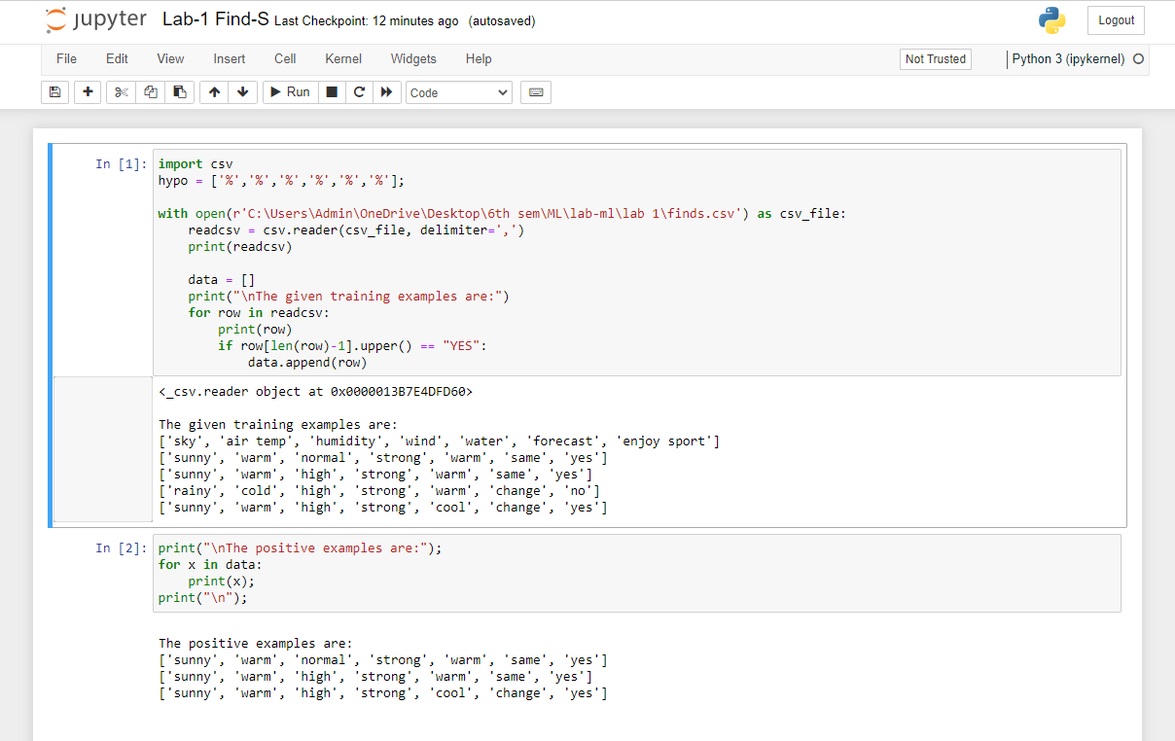

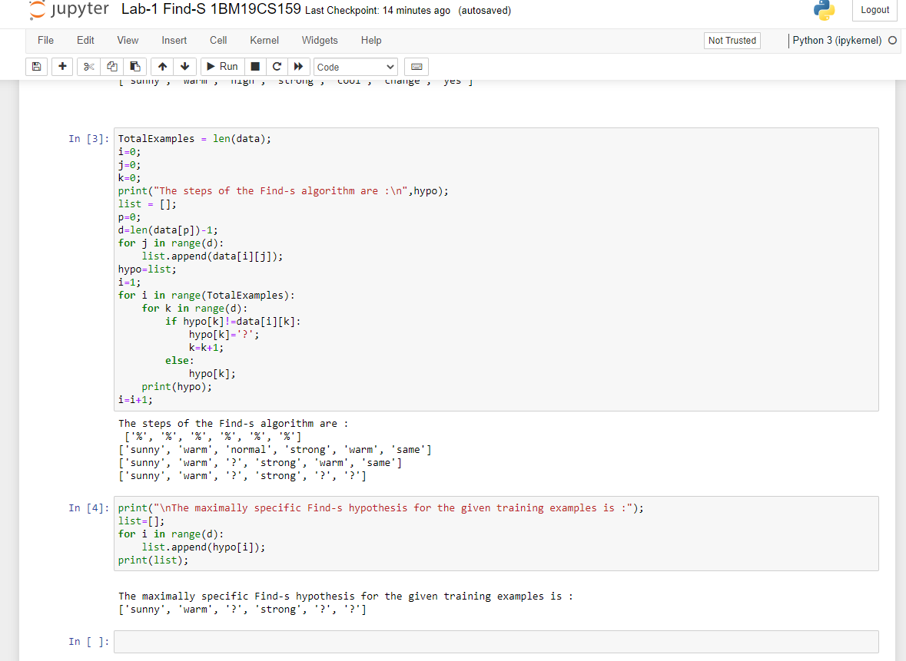

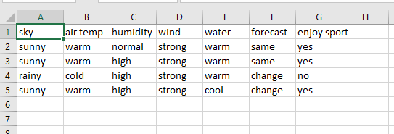

**Lab Program -2 :-**

For a given set of training data examples stored in a .CSV file, implement and demonstrate the Candidate-Elimination algorithm to output a description of the set of all hypotheses consistent with the training examples.

***Source code and output :-***

+*In[7]:*+

[source, ipython3]

----

import numpy as np

import pandas as pd

----

+*In[10]:*+

[source, ipython3]

----

# Loading Data from a CSV File

data = pd.DataFrame(data=pd.read_csv(r'C:\Users\Admin\OneDrive\Desktop\6th sem\ML\lab-ml\lab 2\trainingdata.csv'))

print(data)

----

+*Out[10]:*+

----

sky airtemp humidity wind water forecast enjoySport

0 Sunny Warm Normal Strong Warm Same Yes

1 Sunny Warm High Strong Warm Same Yes

2 Rainy Cold High Strong Warm Change No

3 Sunny Warm High Strong Cool Change Yes

----

+*In[11]:*+

[source, ipython3]

----

# Separating concept features from Target

concepts = np.array(data.iloc[:,0:-1])

print(concepts)

----

+*Out[11]:*+

----

[['Sunny' 'Warm' 'Normal' 'Strong' 'Warm' 'Same']

['Sunny' 'Warm' 'High' 'Strong' 'Warm' 'Same']

['Rainy' 'Cold' 'High' 'Strong' 'Warm' 'Change']

['Sunny' 'Warm' 'High' 'Strong' 'Cool' 'Change']]

----

+*In[12]:*+

[source, ipython3]

----

# Isolating target into a separate DataFrame

# copying last column to target array

target = np.array(data.iloc[:,-1])

print(target)

----

+*Out[12]:*+

----

['Yes' 'Yes' 'No' 'Yes']

----

+*In[13]:*+

[source, ipython3]

----

def learn(concepts, target):

'''

learn() function implements the learning method of the Candidate elimination algorithm.

Arguments:

concepts - a data frame with all the features

target - a data frame with corresponding output values

'''

# Initialise S0 with the first instance from concepts

# .copy() makes sure a new list is created instead of just pointing to the same memory location

specific_h = concepts[0].copy()

print("\nInitialization of specific_h and general_h")

print(specific_h)

#h=["#" for i in range(0,5)]

#print(h)

general_h = [["?" for i in range(len(specific_h))] for i in range(len(specific_h))]

print(general_h)

# The learning iterations

for i, h in enumerate(concepts):

# Checking if the hypothesis has a positive target

if target[i] == "Yes":

for x in range(len(specific_h)):

# Change values in S & G only if values change

if h[x] != specific_h[x]:

specific_h[x] = '?'

general_h[x][x] = '?'

# Checking if the hypothesis has a positive target

if target[i] == "No":

for x in range(len(specific_h)):

# For negative hyposthesis change values only in G

if h[x] != specific_h[x]:

general_h[x][x] = specific_h[x]

else:

general_h[x][x] = '?'

print("\nSteps of Candidate Elimination Algorithm",i+1)

print(specific_h)

print(general_h)

# find indices where we have empty rows, meaning those that are unchanged

indices = [i for i, val in enumerate(general_h) if val == ['?', '?', '?', '?', '?', '?']]

for i in indices:

# remove those rows from general_h

general_h.remove(['?', '?', '?', '?', '?', '?'])

# Return final values

return specific_h, general_h

----

+*In[14]:*+

[source, ipython3]

----

s_final, g_final = learn(concepts, target)

print("\nFinal Specific_h:", s_final, sep="\n")

print("\nFinal General_h:", g_final, sep="\n")

----

+*Out[14]:*+

----

Initialization of specific_h and general_h

['Sunny' 'Warm' 'Normal' 'Strong' 'Warm' 'Same']

[['?', '?', '?', '?', '?', '?'], ['?', '?', '?', '?', '?', '?'], ['?', '?', '?', '?', '?', '?'], ['?', '?', '?', '?', '?', '?'], ['?', '?', '?', '?', '?', '?'], ['?', '?', '?', '?', '?', '?']]

Steps of Candidate Elimination Algorithm 1

['Sunny' 'Warm' 'Normal' 'Strong' 'Warm' 'Same']

[['?', '?', '?', '?', '?', '?'], ['?', '?', '?', '?', '?', '?'], ['?', '?', '?', '?', '?', '?'], ['?', '?', '?', '?', '?', '?'], ['?', '?', '?', '?', '?', '?'], ['?', '?', '?', '?', '?', '?']]

Steps of Candidate Elimination Algorithm 2

['Sunny' 'Warm' '?' 'Strong' 'Warm' 'Same']

[['?', '?', '?', '?', '?', '?'], ['?', '?', '?', '?', '?', '?'], ['?', '?', '?', '?', '?', '?'], ['?', '?', '?', '?', '?', '?'], ['?', '?', '?', '?', '?', '?'], ['?', '?', '?', '?', '?', '?']]

Steps of Candidate Elimination Algorithm 3

['Sunny' 'Warm' '?' 'Strong' 'Warm' 'Same']

[['Sunny', '?', '?', '?', '?', '?'], ['?', 'Warm', '?', '?', '?', '?'], ['?', '?', '?', '?', '?', '?'], ['?', '?', '?', '?', '?', '?'], ['?', '?', '?', '?', '?', '?'], ['?', '?', '?', '?', '?', 'Same']]

Steps of Candidate Elimination Algorithm 4

['Sunny' 'Warm' '?' 'Strong' '?' '?']

[['Sunny', '?', '?', '?', '?', '?'], ['?', 'Warm', '?', '?', '?', '?'], ['?', '?', '?', '?', '?', '?'], ['?', '?', '?', '?', '?', '?'], ['?', '?', '?', '?', '?', '?'], ['?', '?', '?', '?', '?', '?']]

Final Specific_h:

['Sunny' 'Warm' '?' 'Strong' '?' '?']

Final General_h:

[['Sunny', '?', '?', '?', '?', '?'], ['?', 'Warm', '?', '?', '?', '?']]

----

+*In[ ]:*+

[source, ipython3]

----

----

***Output screenshots :-***

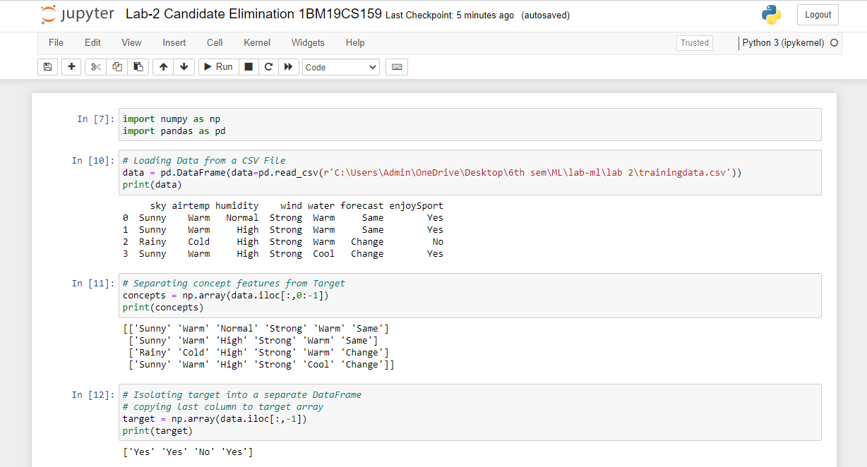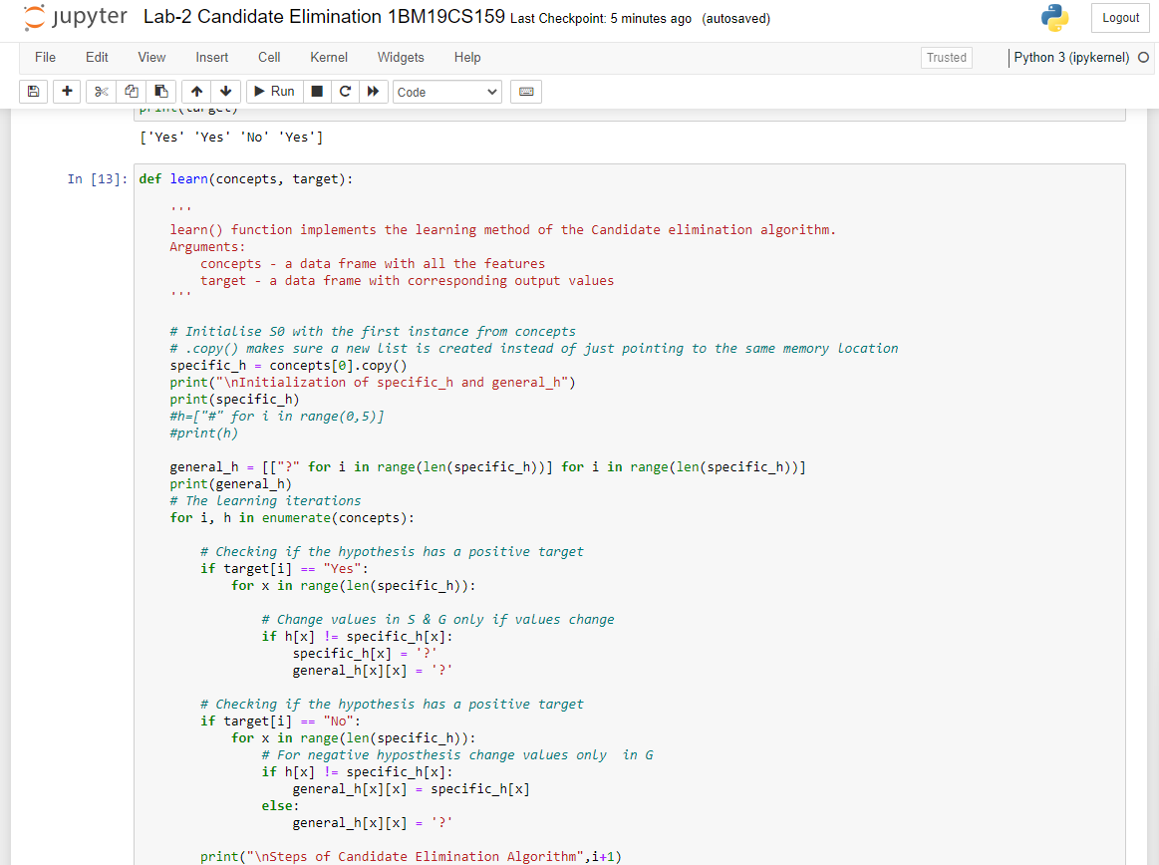

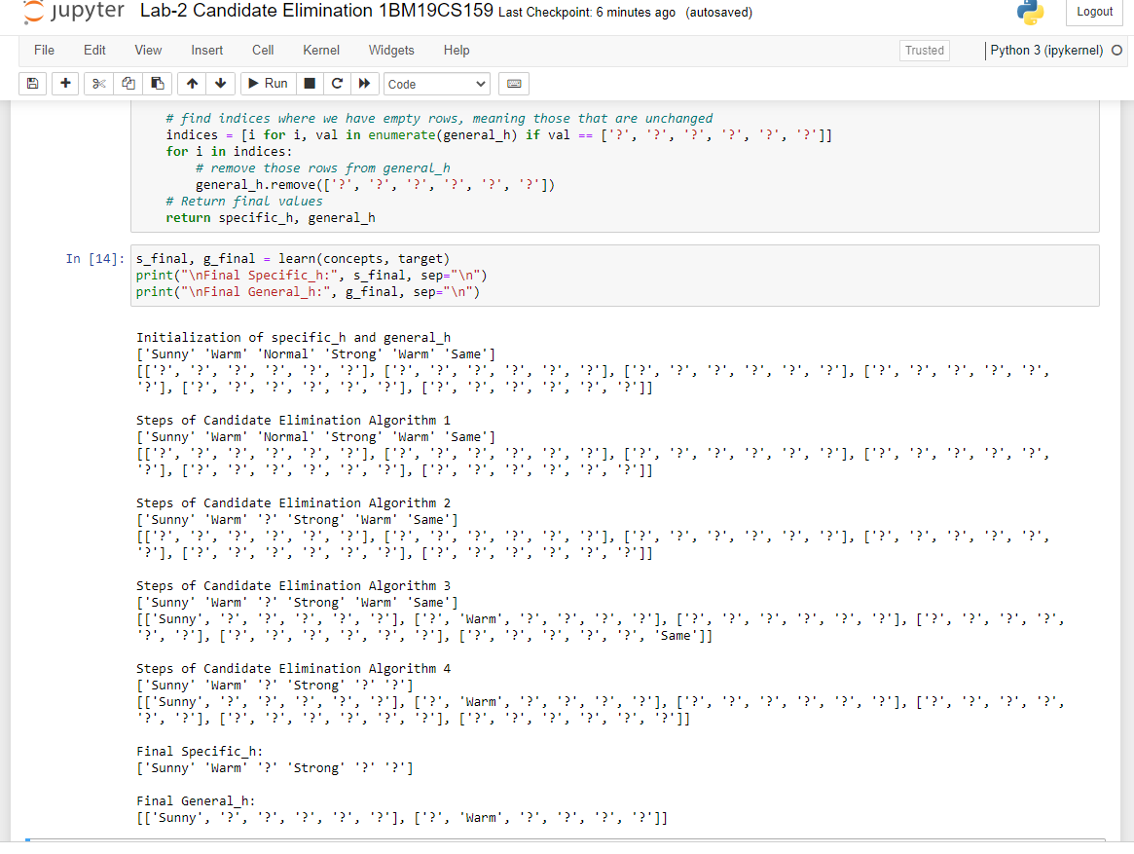

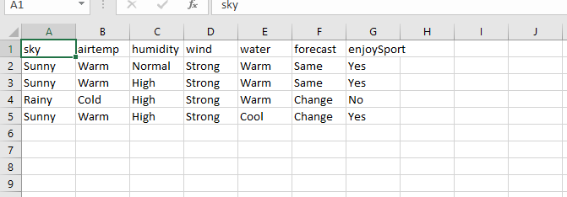

**Lab Program -3 :-**

Write a program to demonstrate the working of the decision tree based ID3 algorithm. Use an appropriate data set for building the decision tree and apply this knowledge to classify a new sample.

***Source code and output :-***

+*In[1]:*+

[source, ipython3]

----

import numpy as np

import math

import csv

----

+*In[2]:*+

[source, ipython3]

----

def read_data(filename):

with open(filename, 'r') as csvfile:

datareader = csv.reader(csvfile, delimiter=',')

headers = next(datareader)

metadata = []

traindata = []

for name in headers:

metadata.append(name)

for row in datareader:

traindata.append(row)

return (metadata, traindata)

----

+*In[5]:*+

[source, ipython3]

----

class Node:

def __init__(self, attribute):

self.attribute = attribute

self.children = []

self.answer = ""

def __str__(self):

return self.attribute

----

+*In[6]:*+

[source, ipython3]

----

def subtables(data, col, delete):

dict = {}

items = np.unique(data[:, col])

count = np.zeros((items.shape[0], 1), dtype=np.int32)

for x in range(items.shape[0]):

for y in range(data.shape[0]):

if data[y, col] == items[x]:

count[x] += 1

for x in range(items.shape[0]):

dict[items[x]] = np.empty((int(count[x]), data.shape[1]), dtype="|S32")

pos = 0

for y in range(data.shape[0]):

if data[y, col] == items[x]:

dict[items[x]][pos] = data[y]

pos += 1

if delete:

dict[items[x]] = np.delete(dict[items[x]], col, 1)

return items, dict

----

+*In[7]:*+

[source, ipython3]

----

def entropy(S):

items = np.unique(S)

if items.size == 1:

return 0

counts = np.zeros((items.shape[0], 1))

sums = 0

for x in range(items.shape[0]):

counts[x] = sum(S == items[x]) / (S.size * 1.0)

for count in counts:

sums += -1 * count * math.log(count, 2)

return sums

----

+*In[8]:*+

[source, ipython3]

----

def gain_ratio(data, col):

items, dict = subtables(data, col, delete=False)

total_size = data.shape[0]

entropies = np.zeros((items.shape[0], 1))

intrinsic = np.zeros((items.shape[0], 1))

for x in range(items.shape[0]):

ratio = dict[items[x]].shape[0]/(total_size * 1.0)

entropies[x] = ratio * entropy(dict[items[x]][:, -1])

intrinsic[x] = ratio * math.log(ratio, 2)

total_entropy = entropy(data[:, -1])

iv = -1 * sum(intrinsic)

for x in range(entropies.shape[0]):

total_entropy -= entropies[x]

return total_entropy / iv

----

+*In[9]:*+

[source, ipython3]

----

def create_node(data, metadata):

if (np.unique(data[:, -1])).shape[0] == 1:

node = Node("")

node.answer = np.unique(data[:, -1])[0]

return node

gains = np.zeros((data.shape[1] - 1, 1))

for col in range(data.shape[1] - 1):

gains[col] = gain_ratio(data, col)

split = np.argmax(gains)

node = Node(metadata[split])

metadata = np.delete(metadata, split, 0)

items, dict = subtables(data, split, delete=True)

for x in range(items.shape[0]):

child = create_node(dict[items[x]], metadata)

node.children.append((items[x], child))

return node

----

+*In[10]:*+

[source, ipython3]

----

def empty(size):

s = ""

for x in range(size):

s += " "

return s

def print_tree(node, level):

if node.answer != "":

print(empty(level), node.answer)

return

print(empty(level), node.attribute)

for value, n in node.children:

print(empty(level + 1), value)

print_tree(n, level + 2)

----

+*In[11]:*+

[source, ipython3]

----

metadata, traindata = read_data(r"C:\Users\Admin\OneDrive\Desktop\6th sem\ML\lab-ml\Lab 3\id3 training dataset.csv")

data = np.array(traindata)

node = create_node(data, metadata)

print_tree(node, 0)

----

+*Out[11]:*+

----

Outlook

overcast

b'yes'

rain

Wind

b'strong'

b'no'

b'weak'

b'yes'

sunny

Humidity

b'high'

b'no'

b'normal'

b'yes'

----

+*In[ ]:*+

[source, ipython3]

----

----

***Output screenshots :-***

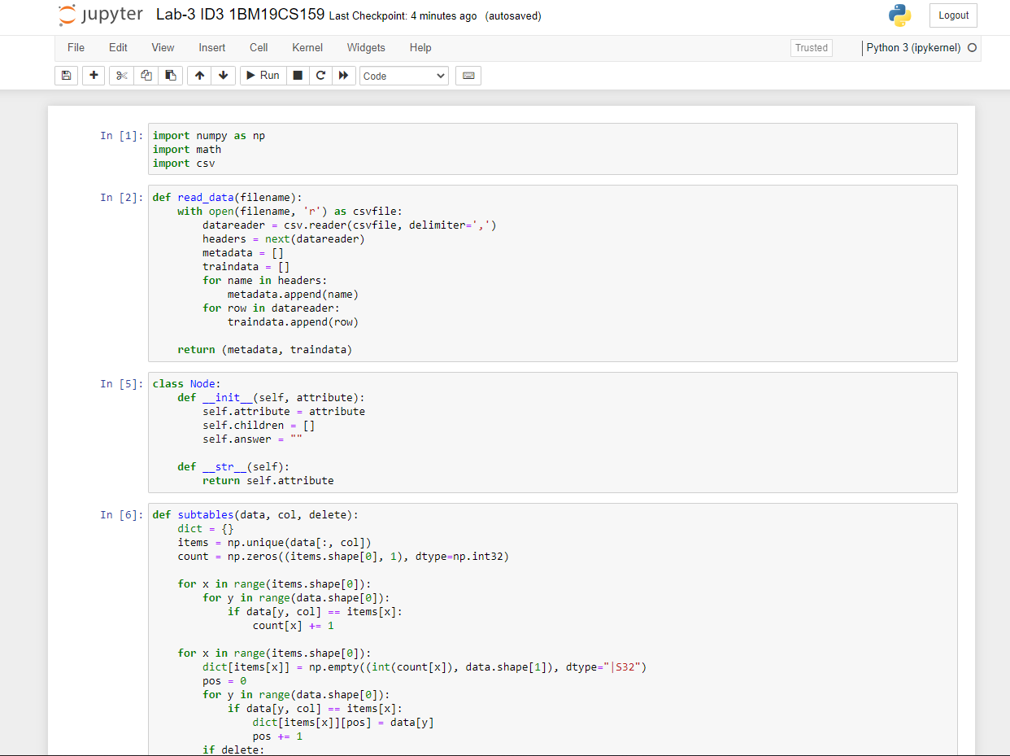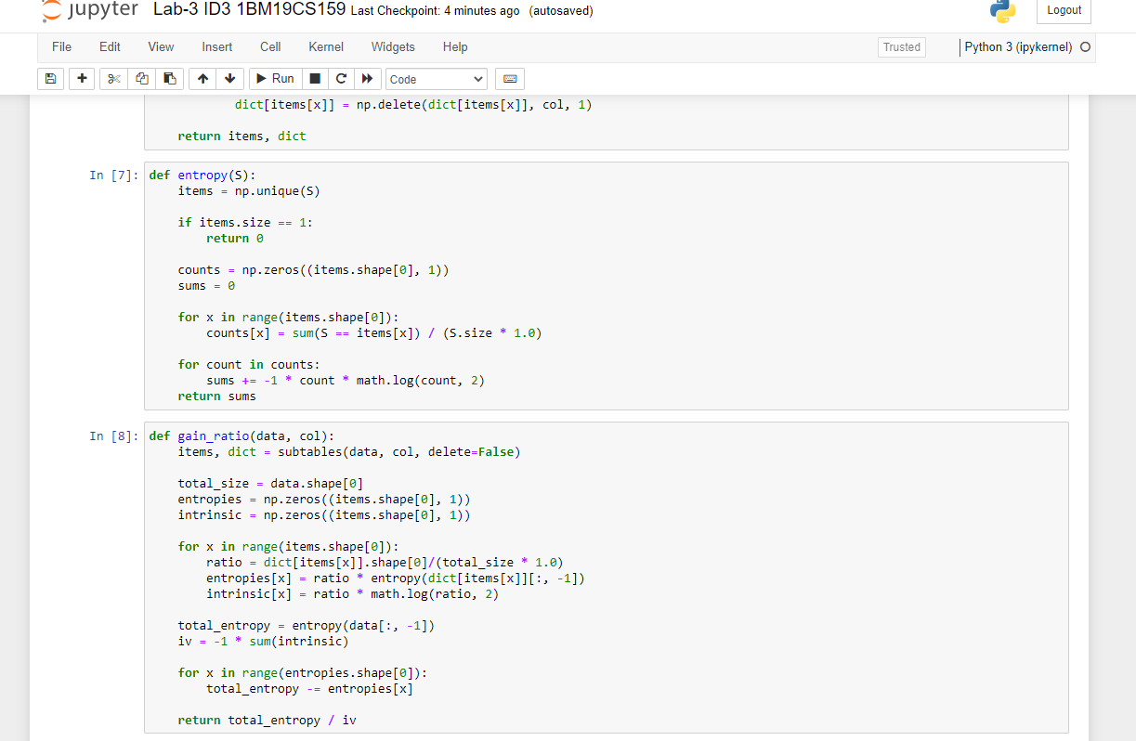

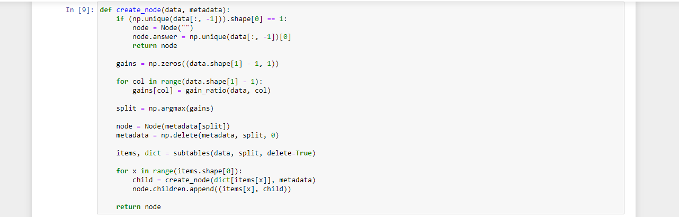 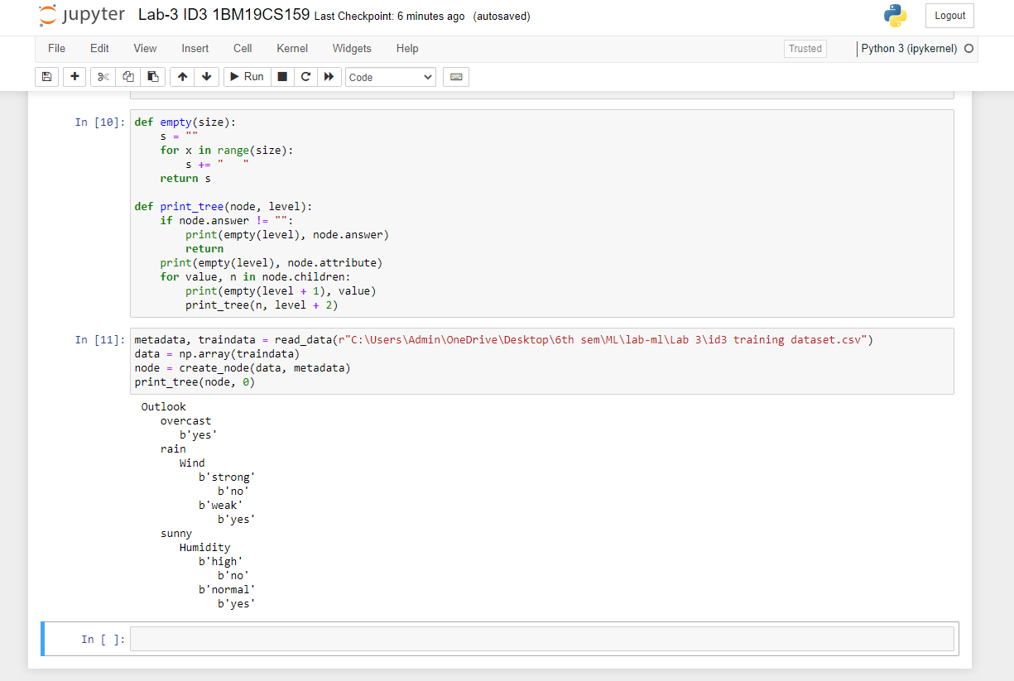 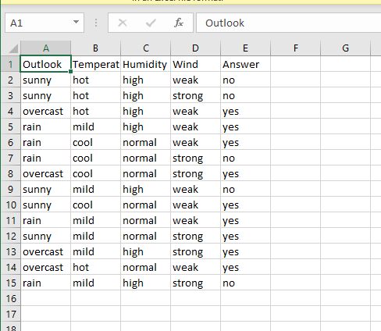

**Lab Program -4.a.:-**

Write a program to implement the naïve Bayesian classifier for a sample training data set stored as a .CSV file. Compute the accuracy of the classifier, considering few test data sets

***Source code and output :-***

+*In[1]:*+

[source, ipython3]

----

# import necessary libarities

import pandas as pd

from sklearn import tree

from sklearn.preprocessing import LabelEncoder

from sklearn.naive_bayes import GaussianNB

# load data from CSV

data = pd.read_csv(r"C:\Users\Admin\OneDrive\Desktop\6th sem\ML\lab-ml\Lab 4\Naive Bayesian classifier training dataset.csv")

print("THe first 5 values of data is :\n",data.head())

----

+*Out[1]:*+

----

THe first 5 values of data is :

Outlook Temperature Humidity Windy PlayTennis

0 Sunny Hot High False No

1 Sunny Hot High True No

2 Overcast Hot High False Yes

3 Rainy Mild High False Yes

4 Rainy Cool Normal False Yes

----

+*In[2]:*+

[source, ipython3]

----

# obtain Train data and Train output

X = data.iloc[:,:-1]

print("\nThe First 5 values of train data is\n",X.head())

----

+*Out[2]:*+

----

The First 5 values of train data is

Outlook Temperature Humidity Windy

0 Sunny Hot High False

1 Sunny Hot High True

2 Overcast Hot High False

3 Rainy Mild High False

4 Rainy Cool Normal False

----

+*In[3]:*+

[source, ipython3]

----

y = data.iloc[:,-1]

print("\nThe first 5 values of Train output is\n",y.head())

----

+*Out[3]:*+

----

The first 5 values of Train output is

0 No

1 No

2 Yes

3 Yes

4 Yes

Name: PlayTennis, dtype: object

----

+*In[4]:*+

[source, ipython3]

----

# Convert then in numbers

le_outlook = LabelEncoder()

X.Outlook = le_outlook.fit_transform(X.Outlook)

le_Temperature = LabelEncoder()

X.Temperature = le_Temperature.fit_transform(X.Temperature)

le_Humidity = LabelEncoder()

X.Humidity = le_Humidity.fit_transform(X.Humidity)

le_Windy = LabelEncoder()

X.Windy = le_Windy.fit_transform(X.Windy)

print("\nNow the Train data is :\n",X.head())

----

+*Out[4]:*+

----

Now the Train data is :

Outlook Temperature Humidity Windy

0 2 1 0 0

1 2 1 0 1

2 0 1 0 0

3 1 2 0 0

4 1 0 1 0

----

+*In[5]:*+

[source, ipython3]

----

le_PlayTennis = LabelEncoder()

y = le_PlayTennis.fit_transform(y)

print("\nNow the Train output is\n",y)

----

+*Out[5]:*+

----

Now the Train output is

[0 0 1 1 1 0 1 0 1 1 1 1 1 0]

----

+*In[6]:*+

[source, ipython3]

----

from sklearn.model_selection import train_test_split

X_train, X_test, y_train, y_test = train_test_split(X,y, test_size=0.20)

classifier = GaussianNB()

classifier.fit(X_train,y_train)

from sklearn.metrics import accuracy_score

print("Accuracy is:",accuracy_score(classifier.predict(X_test),y_test))

----

+*Out[6]:*+

----

Accuracy is: 0.3333333333333333

----

+*In[ ]:*+

[source, ipython3]

----

----

***Output screenshots :-***

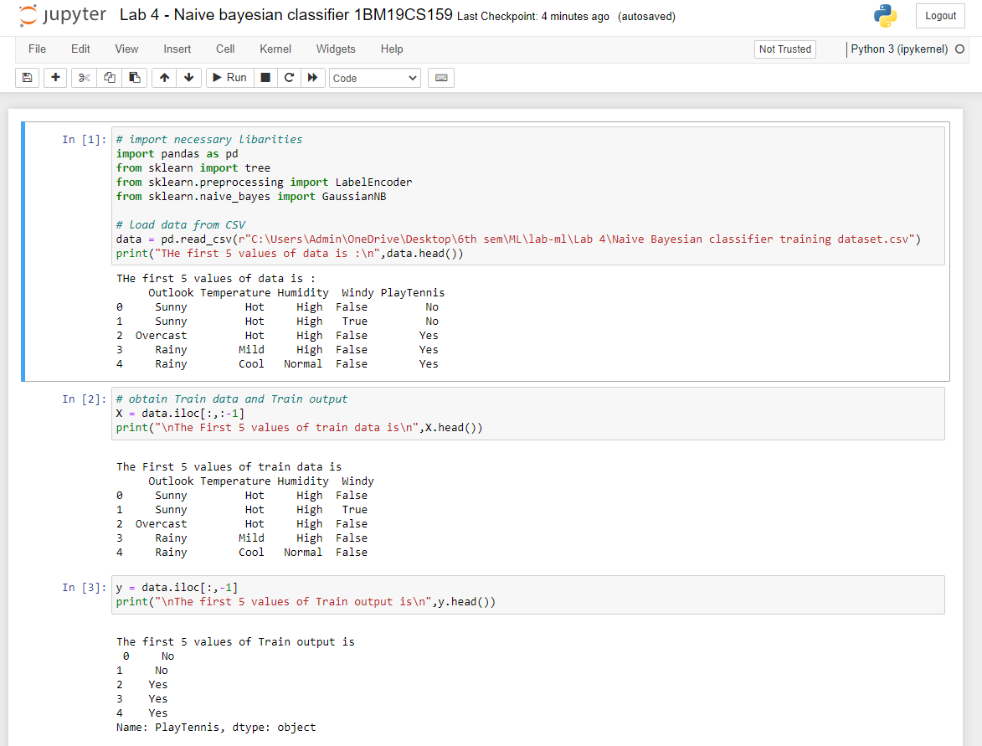

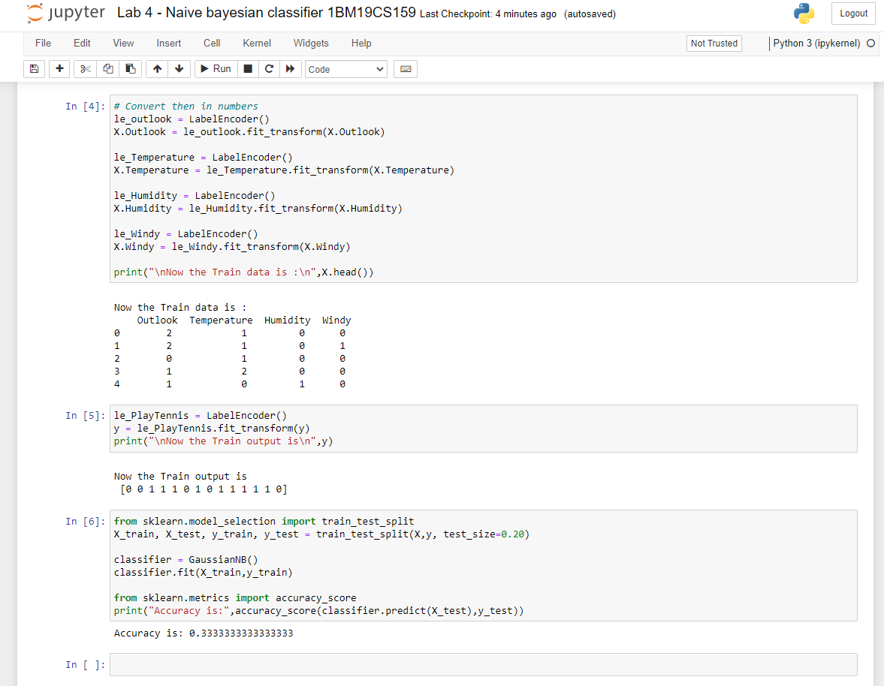

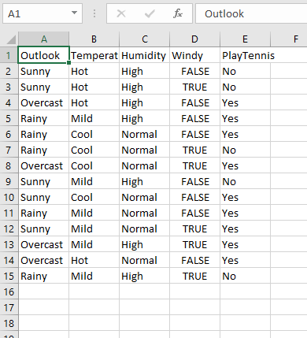

**Lab Program -4.b.:-**

Write a program to implement the naïve Bayesian classifier for a sample training data set stored as a .CSV file. Compute the accuracy of the classifier, considering few test data sets (without packages).

***Source code and output :-***

+*In[1]:*+

[source, ipython3]

----

import math

import csv

import random

----

+*In[2]:*+

[source, ipython3]

----

# This make sures that the dataset is in an ordered format. If we have some arbirary names in that column it difficult to deal with that.

def encode_class(dataset):

classes=[]

for i in range(len(dataset)):

if dataset[i][-1] not in classes:

classes.append(dataset[i][-1])

# Looping across the classes which we have derived above.This will make sure that we have definitive classes (numeric) and not arbitrary

for i in range(len(classes)):

# Looping across all rows of dataset

for j in range(len(dataset)):

if dataset[j][-1] == classes[i]:

dataset[j][-1]=i

return dataset

----

+*In[3]:*+

[source, ipython3]

----

# Splitting the data between training set and testing set. Normally its a general understanding the training:testing=7:3

def train_test_split(dataset,ratio):

test_num=int(ratio*len(dataset))

train=list(dataset)

test=[]

for i in range(test_num):

rand=random.randrange(len(train))

test.append(train.pop(rand))

return train,test

----

+*In[4]:*+

[source, ipython3]

----

# Now depending on resultant value (last column values), we need to group the rows. It will be usefult for calculating mean and std_dev

def groupUnderClass(train):

dict={}

for row in train:

if row[-1] not in dict:

dict[row[-1]]=[]

dict[row[-1]].append(row)

return dict

----

+*In[5]:*+

[source, ipython3]

----

# Standard formulae (just by-heart)

def mean(val):

return sum(val)/float(len(val)) #Obvious

def stdDev(val):

avg=mean(val)

variance=sum([pow(x-avg,2) for x in val])/float(len(val)-1) # Especially this one

return math.sqrt(variance)

----

+*In[6]:*+

[source, ipython3]

----

# We will calculte the mean and std dev with respect to each attribute. Important while calculating gaussian probablity

def meanStdDev(instances):

info=[(mean(x),stdDev(x)) for x in zip(*instances)] # Here we are taking complete column's values of all instances.

del info[-1]

return info

----

+*In[7]:*+

[source, ipython3]

----

# As explained earlier why e need to group. We will be calculating the mean and std dev with respect each class.

def MeanAndStdDevForClass(train):

info={}

dictionary=groupUnderClass(train)

# print(dictionary)

for key,value in dictionary.items():

# dictionary[key]=meanStdDev(value)

info[key]=meanStdDev(value) #Here value stands for a complete group.

return info

----

+*In[8]:*+

[source, ipython3]

----

# Its a formula by heart (no choice)

def calculateGaussianProbablity(x,mean,std_dev):

expo = math.exp(-(math.pow(x - mean, 2) / (2 * math.pow(std_dev, 2))))

return (1 / (math.sqrt(2 * math.pi) * std_dev)) * expo

----

+*In[9]:*+

[source, ipython3]

----

# After calculating mean and std dev w.r.t training data now its time to check if the logic will work on testing data

def calculateClassProbablities(info,ele):

probablities={}

for key,summaries in info.items(): # Info contains the groupName (key) and list of (mean,std_dev) for each attribute of that group

probablities[key]=1

for i in range(len(summaries)): #Loop across all attributes

mean,std_dev=summaries[i]

x=ele[i] # Testing data's one instance's attribute value.

probablities[key] *= calculateGaussianProbablity(x, mean, std_dev)

return probablities

----

+*In[10]:*+

[source, ipython3]

----

def predict(info,ele):

probablities=calculateClassProbablities(info,ele) # returns a dictionary of probablities for each group

bestLabel,bestProb=None,-1

# Consider group name whichever gives you the highest probablities for this instance of testing data

for key,prob in probablities.items():

if bestLabel==None or prob>bestProb:

bestProb=prob

bestLabel=key

return bestLabel

----

+*In[11]:*+

[source, ipython3]

----

# Loop across testing data and store the predicted result from our model in the list.

def getPredictions(info,test):

predictions=[]

for ele in test:

result=predict(info,ele) # This will give you the group to which it will belong.

predictions.append(result)

return predictions

----

+*In[12]:*+

[source, ipython3]

----

def check_accuracy(predictions,test):

count=0

for i in range(len(test)):

if predictions[i]==test[i][-1]:

count+=1

return count/float(len(test))*100

----

+*In[13]:*+

[source, ipython3]

----

filename=r"C:\Users\Admin\OneDrive\Desktop\6th sem\ML\lab-ml\Lab 4\pima-indians-diabetes.csv"

dataset=csv.reader(open(filename))

dataset=list(dataset)

dataset=encode_class(dataset)

for i in range(len(dataset)):

dataset[i]=[float(x) for x in dataset[i]]

ratio=0.3

print(len(dataset))

train,test=train_test_split(dataset,ratio)

info=MeanAndStdDevForClass(train)

predictions=getPredictions(info,test)

accuracy=check_accuracy(predictions,test)

accuracy

----

+*Out[13]:*+

----

768

75.21739130434783----

+*In[ ]:*+

[source, ipython3]

----

----

***Output screenshots :-***

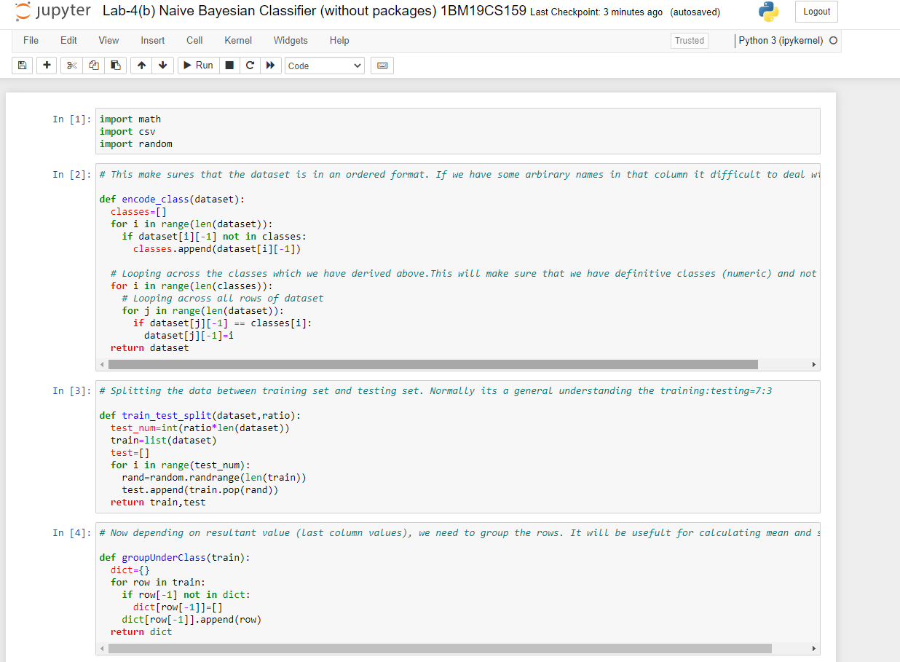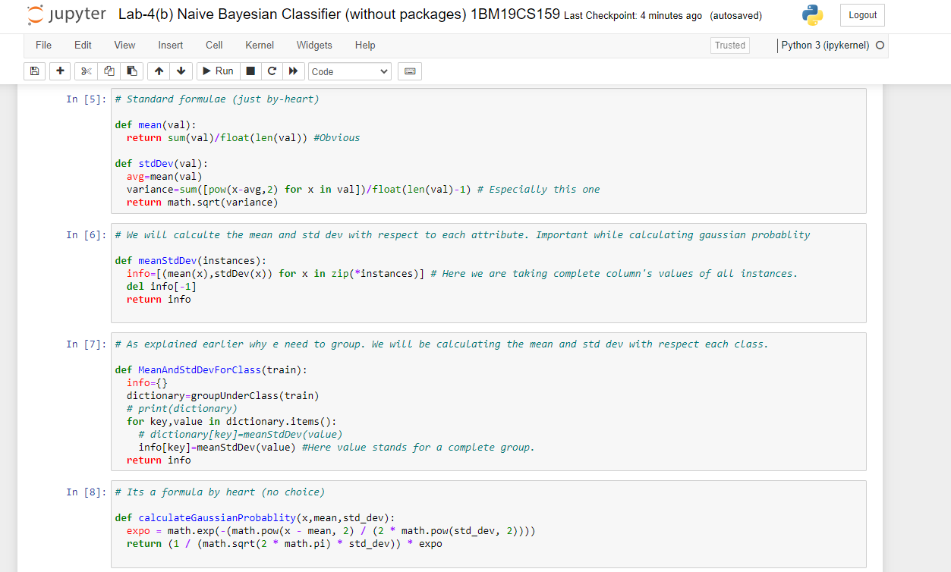

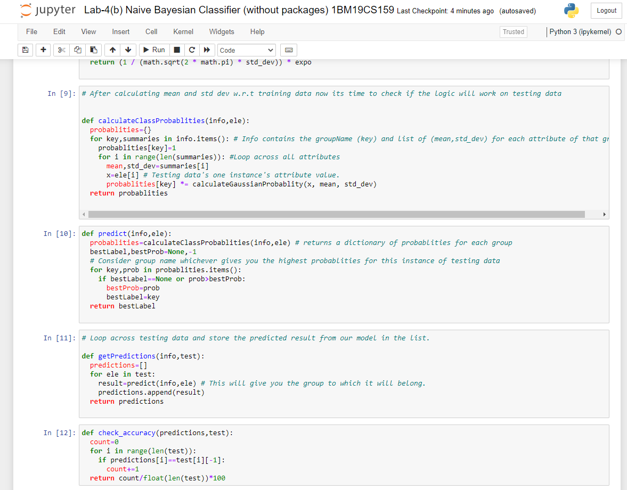 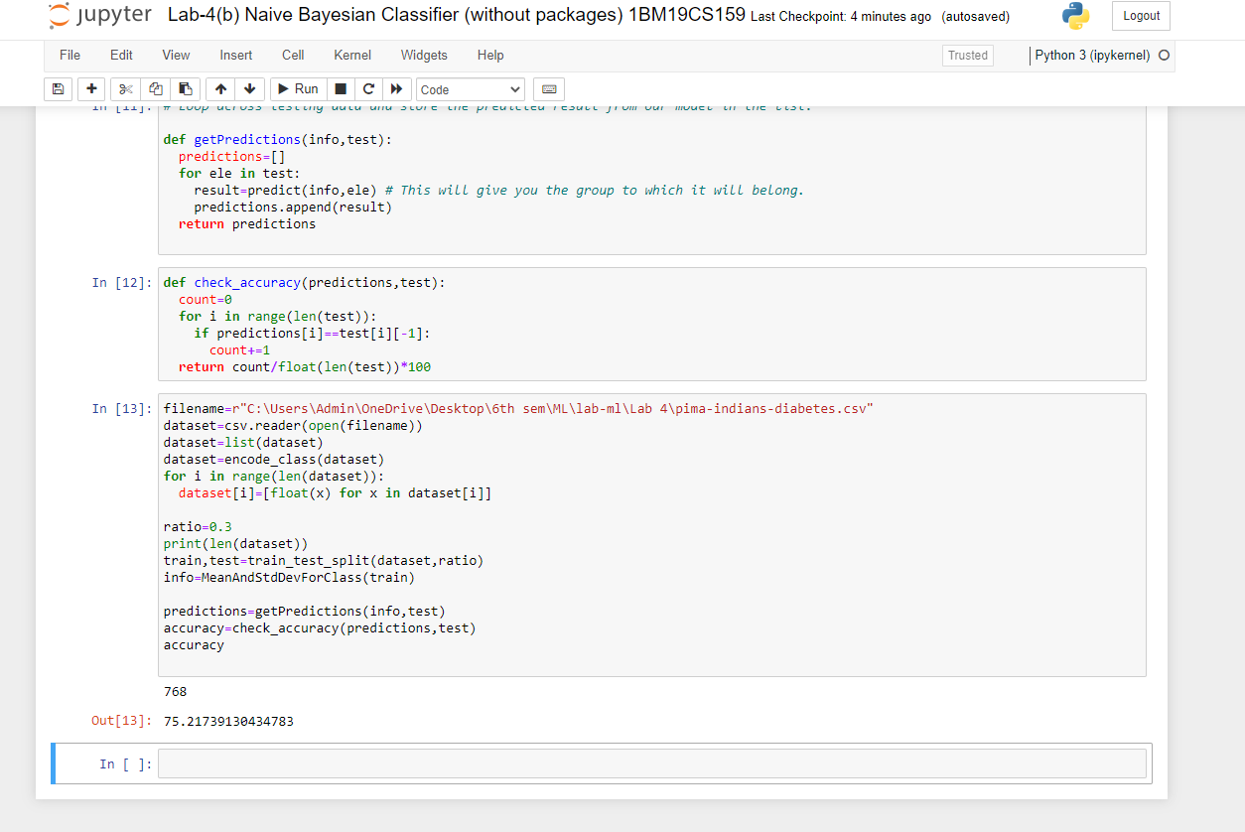

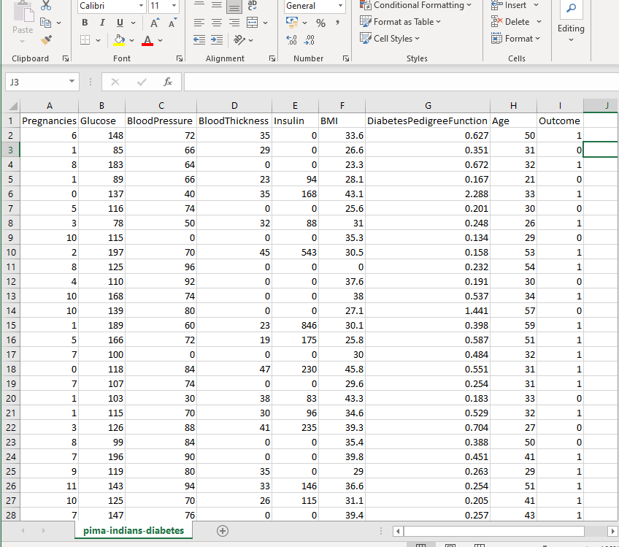

**Lab Program -5.:-**

Implement the Linear Regression algorithm in order to fit data points. Select appropriate data set for your experiment and draw graphs.

***Source code and output :-***

+*In[1]:*+

[source, ipython3]

----

import numpy as np

import matplotlib.pyplot as plt

import pandas as pd

----

+*In[11]:*+

[source, ipython3]

----

dataset = pd.read_csv(r"C:\Users\Admin\OneDrive\Desktop\6th sem\ML\lab-ml\Lab 5\Lr-Salary Dataset.csv")

X = dataset.iloc[:, :-1].values

y = dataset.iloc[:, 1].values

----

+*In[13]:*+

[source, ipython3]

----

from sklearn.model_selection import train_test_split

X_train, X_test, y_train, y_test = train_test_split(X, y, test_size=1/3, random_state=0)

----

+*In[14]:*+

[source, ipython3]

----

# Fitting Simple Linear Regression to the Training set

from sklearn.linear_model import LinearRegression

regressor = LinearRegression()

regressor.fit(X_train, y_train)

----

+*Out[14]:*+

----LinearRegression()----

+*In[15]:*+

[source, ipython3]

----

# Predicting the Test set results

y_pred = regressor.predict(X_test)

----

+*In[19]:*+

[source, ipython3]

----

# Visualizing the Training set results

viz_train = plt

viz_train.scatter(X_train, y_train, color='red')

viz_train.plot(X_train, regressor.predict(X_train), color='blue')

viz_train.title('Salary VS Experience (Training set)')

viz_train.xlabel('Year of Experience')

viz_train.ylabel('Salary')

viz_train.show()

----

+*Out[19]:*+

----

![png](output_5_0.png)

----

+*In[17]:*+

[source, ipython3]

----

# Visualizing the Test set results

viz_test = plt

viz_test.scatter(X_test, y_test, color='red')

viz_test.plot(X_train, regressor.predict(X_train), color='blue')

viz_test.title('Salary VS Experience (Test set)')

viz_test.xlabel('Year of Experience')

viz_test.ylabel('Salary')

viz_test.show()

----

+*Out[17]:*+

----

![png](output_6_0.png)

----

+*In[ ]:*+

[source, ipython3]

----

----

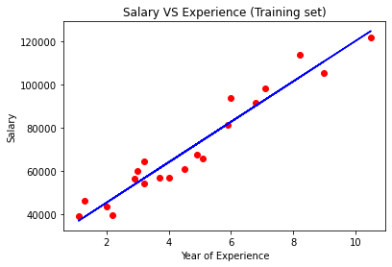

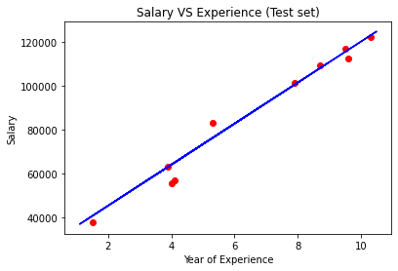

***Output screenshots :-***

